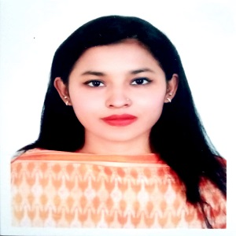

**CAREER OBJECTIVES**

I am seeking an opportunity to intern with an organization and to maximize my potential as a youth by working with teams that can help me to reach my goal and achieve success. As an energetic, dynamic, self-motivated, and passionate individual, I want to achieve a professional breakthrough.

**Farjana Akther**

**Address: 1/24 d South Mugda para Contact info: 01630547998 Email: farzanarahi49@gmail.com**

**Academic Qualifications**

|  |  |  |  |
| --- | --- | --- | --- |
| Year | Examination | Institution | Grade |
| 2022 | IBA(MBA) | JAHANGIRNAGAR UNIVERSITY (last semester)) | 3.41 |
| 2021 | BBA  (Accounting) | DHAKA CITY COLLEGE | 3.49 |
| 2015 | HSC | MOTIJHEEL IDEAL SCHOOL AND COLLEGE | 4.67 |
| 2013 | SSC | MOTIJHEEL IDEAL SCHOOL AND COLLEGE | 5.00 |

**Reference**

**Jannatul Ferdous Lata** Assistant Professor Dhaka City College Email: [lata.ais@gmail.com](mailto:lata.ais@gmail.com) Cell no: 01521256362

**Hard Skills**

Microsoft word, Microsoft Excel, Advance Excel.

**Soft Skills**

Problem Solving, Communication Skill, Team work, Leadership, Negotiation

**Language**

Bangla and English

**Extra Curriculum Activities**

Hand Ball Player (ex-member of Ideal sporting club), Participated in ice breaking program and won the 1st prize.

**Workshop**

Participated in PMP (Project Management Professional) Workshop

Participated in YSSE (Youth School for Social Entrepreneur) Workshop **Training**

Advance excel from coders trust

Computer training from National Youth Development Training Institute

**Mohammad Nazmul Islam**

Associate Professor

IBA, Jahangirnagar University

Email: bulbul_ju@juniv.edu

Contact no: 01716431626